**Project Design Phase-II**

**Data Flow Diagram & User Stories**

|  |  |
| --- | --- |
| Date | 03 October 2022 |
| Team ID | PNT2022TMID10029 |
| Project Name | Project – AI-based localization and classification of Skin Disease with Erythema. |
| Maximum Marks | 4 Marks |

**Data Flow Diagrams:**

A Data Flow Diagram (DFD) is a traditional visual representation of the information flows within a system. A neat and clear DFD can depict the right amount of the system requirement graphically. It shows how data enters and leaves the system, what changes the information, and where data is stored.

Example: DFD Level 0 (Industry Standard)

**Example:** [**(Simplified)**](https://developer.ibm.com/patterns/visualize-unstructured-text/)

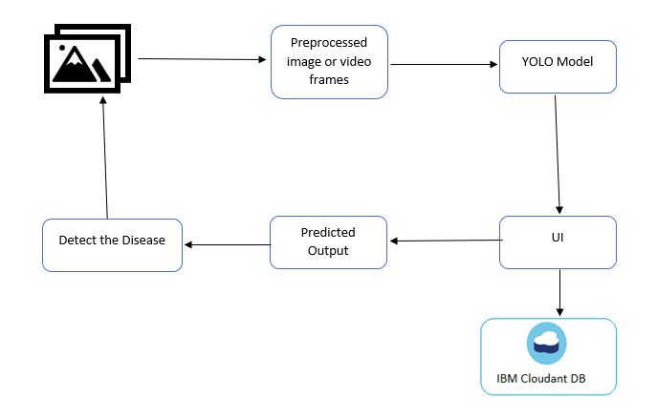

Converts the Image to Report

**No**

If its Skin Disease

Error

**Yes**

Report will be provided

Stop

**User Stories**

Use the below template to list all the user stories for the product.

| **User Type** | **Functional Requirement (Epic)** | **User Story Number** | **User Story / Task** | **Acceptance criteria** | **Priority** | **Release** |
| --- | --- | --- | --- | --- | --- | --- |
| Customer (Mobile user) | Registration | USN-1 | As a user, I can register for the application by entering my email, password, and confirming my password. | I can access my account / dashboard | High | Sprint-1 |
|  | Login and Dashboard | USN-2 | As a user, I can get into the user dashboard to access the contents |  | Medium | Sprint-1 |
| Customer (Mobile user) | Main page | USN-2 | As a user, I will be able to use the application to start rectifying my Skin Disease | I can enter the main page to encounter the usability of the app | Medium | Sprint-1 |
| Customer (Mobile user) | Camera | USN-3 | As a user, I can Capture my Skin | I can do the actions for the camera to capture | High | Sprint-2 |
| Customer (Mobile user) | Voice Control | USN-4 | As a user, I will not use any Voice to find the Skin Disease. |  | Medium | Sprint-1 |
|  | Skin Disease report | USN-5 | As a user, The Captured Skin will find the type of disease and provides the report. | I convert the captured image to report output | High | Sprint-1 |
| Customer (Mobile user) | Guidelines | USN-6 | As a user, I can follow the given guidelines to know about the application and how to use | I can read the guidelines to use the app | Low | Sprint-1 |
| Customer Care Executive | Functionalities and usability of the app |  | As an executive, I can provide the necessary functionalities that a user can use according to their needs | I can provide the required factors to use the app | Medium | Sprint-1 |
| Customer Care Executive | The performance of the application |  | As an executive, I can gather user app status to check and optimize the performance of the app | Collect application performance status | Medium | Sprint-1 |
| Administrator | Receive user feedbacks and queries |  | As an administrator, I can accept user feedbacks and queries related to the app and provide the necessary resolution | Provide resolution based on feedbacks and queries | High | Sprint-2 |